

DATABASE APPLICATIONS
(240)

NATIONAL 2020

Production:

Printout 1: Dog Table (45 points)

Printout 2: Relationships Table (20 points)

Printout 3: Dog Intake Form Print Screen (40 points)

Printout 4: Food Order Query (30 points)

Printout 5: Food Order Report (40 points)

Printout 6: Rabies Vaccine Query (40 points)

TOTAL POINTS (215 points)

Judge/Graders: Please double check and verify all scores and answer keys!

Property of Business Professionals of America.
May be reproduced only for use in the Business Professionals of America
Workplace Skills Assessment Program competition.

DATABASE APPLICATIONS
SCORING SHEET

Unless indicated otherwise, student receives all points or none. | Points Possible | Points Earned
Printout 1 – Dog Table (45 points maximum)
Imported spreadsheet fields correctly (6 fields at 5 points a field) | 30
Sorted by Class (smallest to largest) | 5
Added Adopted field and updated 10 records. | 5
Printed using best fit in portrait orientation (all data shows, 1 page) | 5
Misspellings or wrong data entered -1/2 pt per occurrence up to -10 max. Should also be 0 points for imported spreadsheet correctly.
Printout 2 – Relationship Report (20 points maximum)
Title is Relationships for National XX-XXXX-XXXX | 5
One-to-Many relationship show between Class ID and Class fields. | 15
Printout 3 – Dog Intake Form PrintScreen (40 points maximum)
Created a form with the correct fields (6 fields at 2 points a field). | 12
Gender and Class fields are combo boxes (signified by the down arrow on the printout) (10 points each) | 20
One button (Add New Record) has been added. | 3
Form is laid out, so it is easy to read and understand. | 5
Printout 4 – Food Order Query (30 points maximum)
Title is Food Order Query XX-XXXX-XXXX. | 5
Correct fields were added to the query (4 fields at 3 points a field) | 12
Criteria was used to only display the Dogs that have NOT been adopted. | 13
Printout 5 – Food Order Report (40 points maximum)
Title is Food Order Report XX-XXXX-XXXX | 5
Correct fields are included in the report (2 fields x 3 points each) | 6
Groups are only showing summary details. | 10
Label to Grand Total changed to “Total Cups of Dog Food per Day” | 5
Calculation and label added to determine how much dog food to order for the month. | 10
Printed in portrait orientation all data is visible. | 4
Printout 6 –Rabies Vaccine Query (40 points max)
Correct four fields were included from the Dog Table. (4 at 2 points each) | 8
Correct criteria entered for the Apx DOB field. | 15
Correct criteria entered for the Adopted field. | 10
All field titles and entries can be completely seen (no hidden or truncated) | 2
Printed in portrait orientation. | 5
Total Points Earned | 215

General Instructions
You have been hired as a database specialist and will be assisting on various activities throughout Professional Business Associates, located at 5454 Cleveland Avenue, Columbus, Ohio 43231. Professional Business Associates provides accounting, software, programming and other services for clients.

- You will have 90 minutes to complete your work.

- Check that you have all the test pages.

- Your name, initials, and school should not appear on any work you submit. Instead, type your contestant number everywhere XX-XXXX-XXXX appears.

- If you finish before the end of the testing time, notify the administrator of the contest. Time may be a factor in determining a winner when there is a tie score.

- When turning in your completed work, order the printed pages by job number, and place your scoring sheet on top of all your jobs. Turn in all pages printed including incorrect printouts (draw a line through each incorrect printout and place it at the back of the group).

Print 1 – Dog Table xx-xxxx-xxxx
.
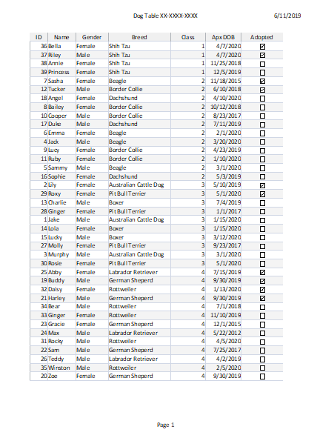

Print 2 – Relationship Table xx-xxxx-xxxx

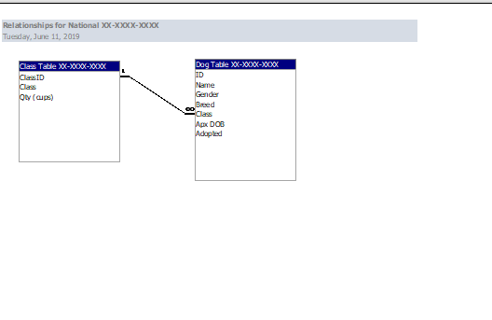

Print 3 – Dog Intake Form Printscreen

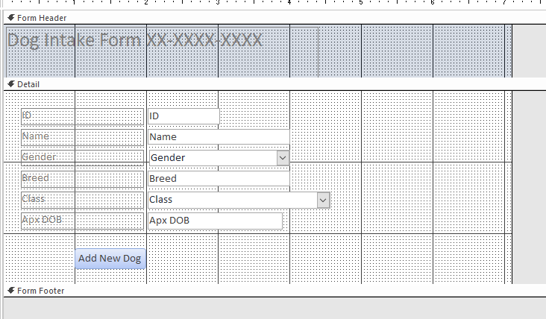

Print 4 – Food Order QueryXX-XXXX-XXXX

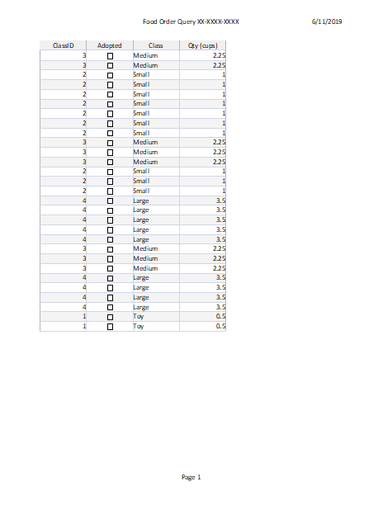

Print 5 – Food Order Report XX-XXXX-XXXX

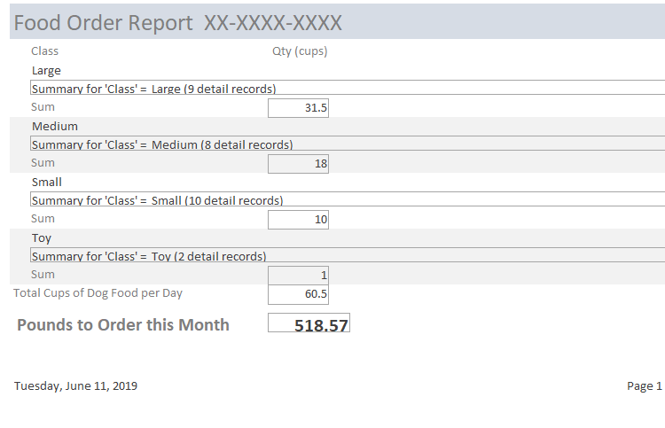

Print 6 – Rabies Vaccine Query XX-XXXX-XXXX

